Q1. How much each group type contributes to total group revenue in 2018, broken down by quarter.

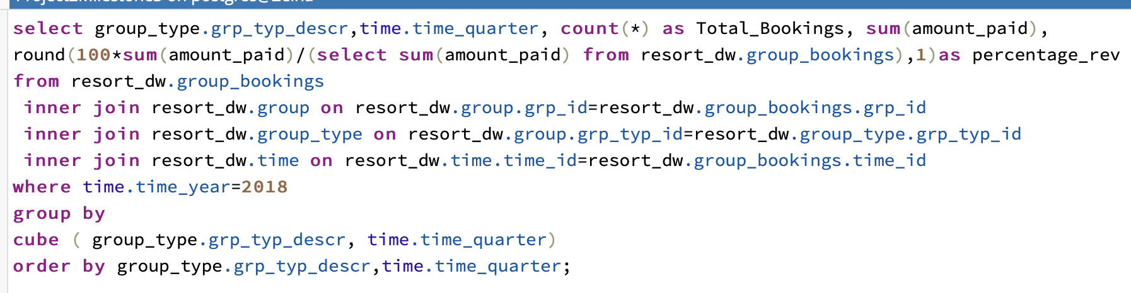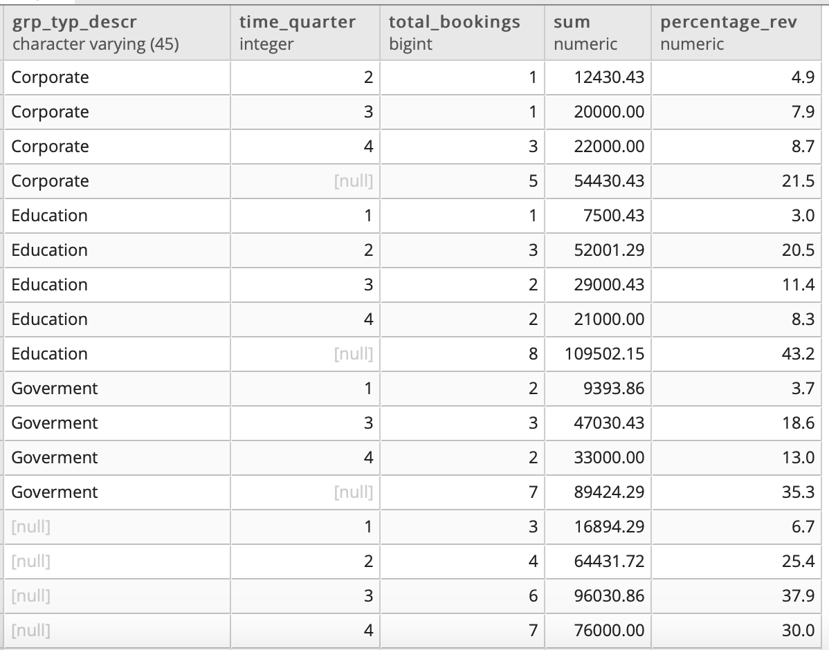

Q 2. How does the purpose of event bookings change throughout the year?

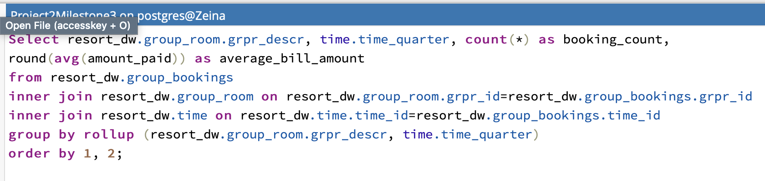

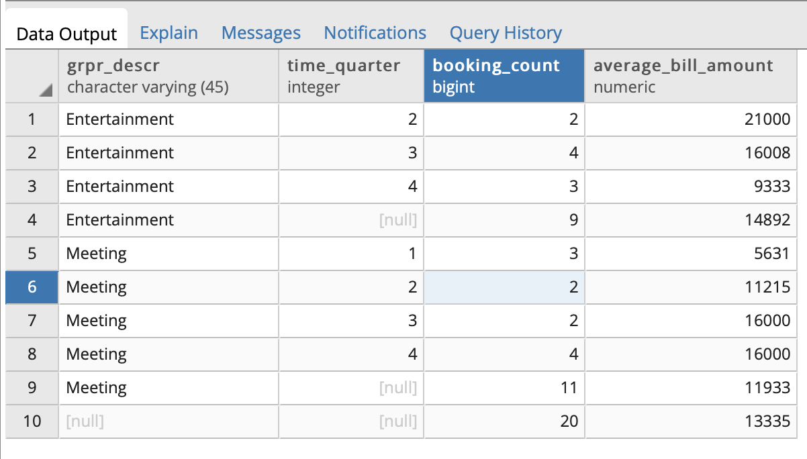

Q 3. How long and how often are resorts booked for events